Internal Data Collection Guide (EcoHealth Analytics Platform)
Section 1 – Environmental Data
- Governorate → Location identifier; needed for mapping pollution hotspots.
- Year/Month/Season → Time dimension; shows seasonal spikes.
- PM2.5, PM10, NO2 → Core pollutants; directly linked to respiratory/cardiovascular illness.
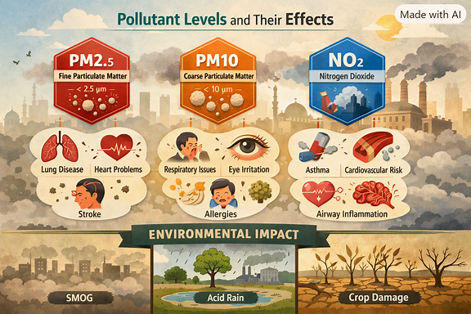
- Meteorology (Temp, Humidity, Wind, Solar Radiation) → Modifiers; explain why pollution rises/falls.
Section 2 – Health Outcomes
- Respiratory illness cases → Direct measure of pollution’s health burden.
- Hospital admissions → Shows healthcare system strain.
- Mortality rates → Indicates severity of pollution impact.
- DALYs → Combines illness + death into one burden metric.
Section 3 – Economic Indicators
- Healthcare costs → Direct financial impact.
- Lost productivity → Indirect costs from sick workers.
- GDP impact / Cost per DALY → Connects health burden to national economy.
Section 4 – Machine Learning & AI Features
- Lagged pollution variables → Past values improve prediction accuracy.
- Seasonal indicators → Capture winter/summer spikes.
- Population density / Industrial activity → Drivers of pollution.
- Policy interventions → Needed for scenario simulations.
- AI forecasts → Predict future risks and costs.
Section 5 – Dashboard & Reporting
- Geospatial mapping → Heatmaps of governorates.
- KPI cards → Quick summary (pollution, admissions, costs).
- Filters → Year, Governorate, Season, Pollutant type.
- Predictive insights → AI/ML projections for decision-makers.
Visuals to Include
- Pollutant illustration (the one we already made).
- Merged infographic showing the flow:
  - Environmental → Health → Economic → AI/ML → Dashboard → Policy.

